Common problems and solutions with Audacity

To get audio onto your computer-
Italk-
• With your device connected open iTunes
• Select your iPod, iPhone or iPad under devices
• Select Apps from the top of the iTunes Window
• Scroll all the way to the bottom until you see File Sharing
• Select iTalk under File Sharing
• Your recordings will be on the right, you can drag and drop those files to your desktop or any other folder
Zoom 1 recorders
Turn recorder off
Attach USB cables
Recorder will pop up like a flash drive
Audio will be in folder labeled “Stereo”
From a web site like wphs.weebly.com
right click and save target to your student drive.
To record from a website
Make sure Windows WASPI is selected
Press Record
Play the audio on the web site
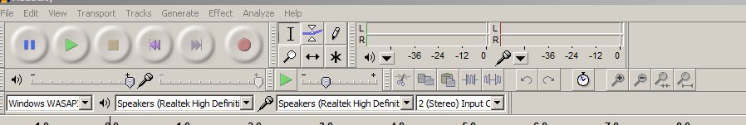

To get audio into audacity- it’s called importing
File- import- audio- (wherever you saved the audio)
IT’S NOT FILE AND OPEN
To open a project you’ve been working on
File/Open/ Choose the audacity project file (.aup)
To Save a project you’ve been working on
File/save project
You sent the wrong file!
.AUP and .WAV
An .AUP file is an audacity project file
A .WAV file is an audio file
When you choose save project you get a .AUP file
When you choose export you get a .wav file
For finished projects I need the .wav file or a .mp3 file not the audacity project file (.aup)

To split an audio track
place cursor where you want to split the track
go to: Edit/Clip Boundaries and split
To move a track
Select this button then click and drag
To lower volume of a specific part of a track
Select the audio by dragging cursor over it
Go to: Effect/Amplify go up adds volume going down decreases- you must allow clipping
You can go to youtube and search how to do just about anything in audacity and find a video explaining it.

