Client: EPA
Title: Report Card
Length: :30

Music should be Vivaldi Four Seasons
(SFX: Door slams shut, footsteps, keys drop on table)
WOMAN: HI, I´M HOME. ANY MAIL TODAY?
MAN: NOTHING TOO EXCITING. JUST DAVID´S REPORT CARD AND SOMETHING FROM THE WATER COMPANY.
WOMAN: ANOTHER WATER BILL?
MAN: I DON´T KNOW- ´DIDN´T OPEN IT.
(SFX: Paper rustling/envelope being torn open)
WOMAN: [NOT PLEASED] DAVID´S REPORT CARD COULD BE BETTER. [HAPPIER] BUT THIS IS INTERESTING. THE WATER COMPANY SENT US A REPORT ABOUT THE QUALITY OF OUR TAP WATER AND WHERE IT COMES FROM.
MAN: AND?
WOMAN: OUR WATER PASSED ALL ITS TESTS UNLIKE SOME PEOPLE AROUND HERE.
(MUSIC: UP AND UNDER)

(MORE MORE MORE MORE MORE MORE MORE MORE MORE MORE MORE MORE MORE MORE)

ANNCR: YOU´LL ALSO BE RECEIVING A SHORT, NEW REPORT ABOUT YOUR TAP WATER FROM YOUR WATER SUPPLIER. LOOK FOR IT. AND WHEN IT COMES, READ IT. FOR MORE INFORMATION, CALL YOUR WATER SUPPLIER OR EPA'S SAFE DRINKING WATER HOTLINE (800-426-4791).
(MUSIC: Out)
.

Delete the following text and picture when done reading and using this tip. The picture below is an example of how you apply style. When you click on the style it makes the paragraph of text your cursor is on look like that style.

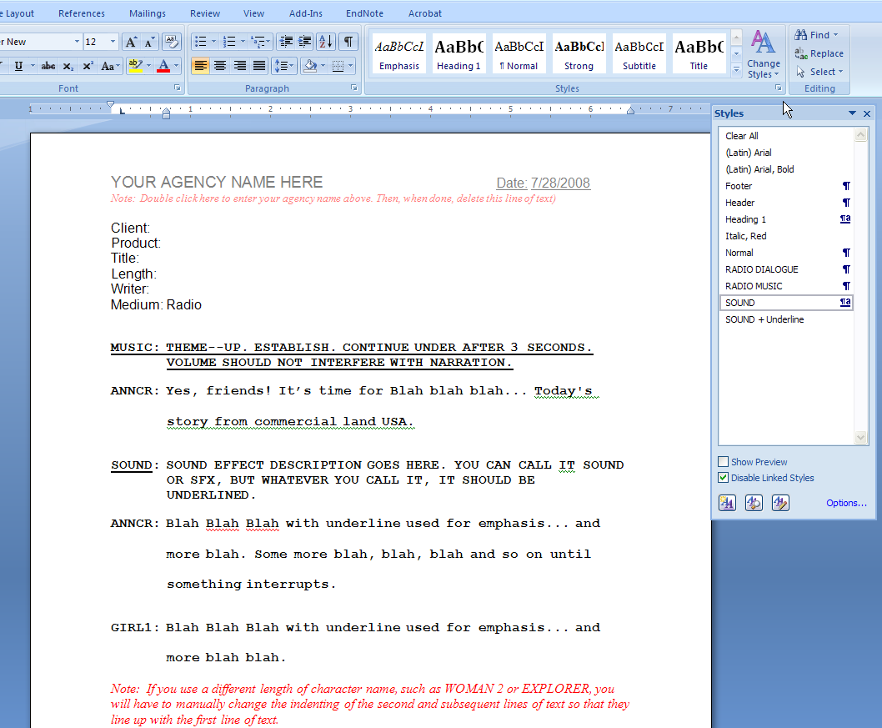Special note. When you underline the word sound it creates a style that says SOUND + Underline. Do not use that as a style in the future because it will underline all the words. Use SOUND and always manually add the underline to the word SOUND or SFX
Click here to reveal styles

